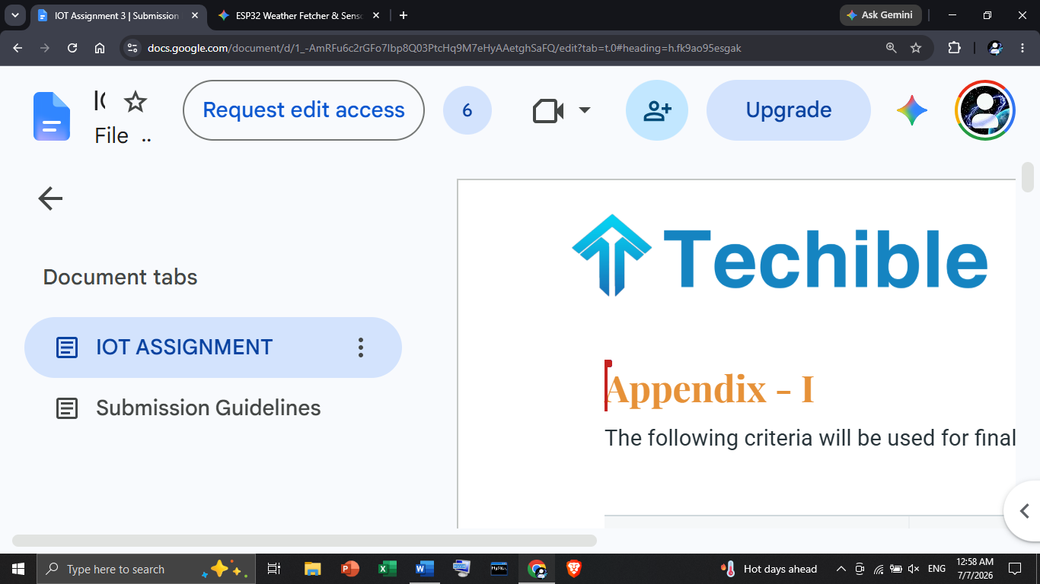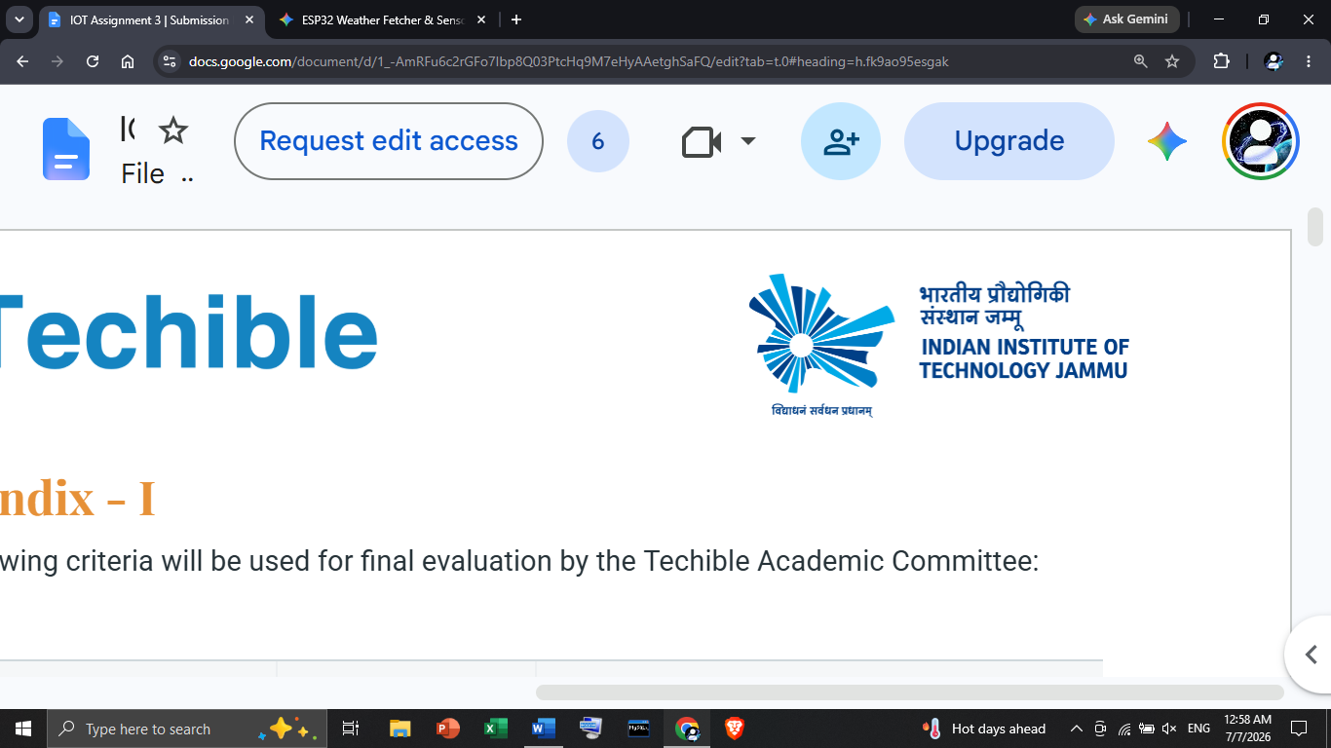
IOT Assignment 3

• Student Name: Harsh Vardhan Singh
• Enrollment / Roll Number:
• Course Name: Internet of Things and Drones
• Assignment Title: IoT Summer School Assignment
• Submission Date: July 7,2026

Q35. REST API – Weather Data Fetcher
config.h file code:-
#define CONFIG_H
#define CONFIG_H
const char* WIFI_SSID = "Poco X6 Pro";
const char* WIFI_PASSWORD = "00001234";
const char* API_KEY = "https://api.open-meteo.com/v1/forecast?latitude=52.52&longitude=13.41&hourly=temperature_2m,relative_humidity_2m&current=temperature_2m&timezone=Asia%2FSingapore";
const char* CITY_NAME = "Delhi";
const char* COUNTRY_CODE = "IN";
#define

Weather_Data_Fetching code:-
#include <WiFi.h>
#include <HTTPClient.h>
#include <ArduinoJson.h>
#include "DHT.h"
#include "config.h"
#define DHTPIN 4
#define DHTTYPE DHT11
DHT dht(DHTPIN, DHTTYPE);
unsigned long lastTime = 0;
const unsigned long timerDelay = 600000;
void setup() {
Serial.begin(115200);
dht.begin();
Serial.print("Wi-Fi se connect ho raha hai...");
WiFi.begin(WIFI_SSID, WIFI_PASSWORD);
while (WiFi.status() != WL_CONNECTED) {
delay(500);
Serial.print(".");
}
Serial.println("\nConnected! IP Address: " + WiFi.localIP().toString());
fetchWeatherAndCompare();
}
void loop() {
if (millis() - lastTime > timerDelay) {
fetchWeatherAndCompare();
lastTime = millis();
}}
void fetchWeatherAndCompare() {
float localTemp = dht.readTemperature();
float localHum = dht.readHumidity();
bool sensorError = false;
if (isnan(localTemp) || isnan(localHum)) {
Serial.println("Warning: DHT11 sensor read nahi ho raha! Wiring check kar.");
sensorError = true;}
if (WiFi.status() == WL_CONNECTED) {
HTTPClient http;
String url = "http://api.openweathermap.org/data/2.5/weather?q=" +
String(CITY_NAME) + "," + String(COUNTRY_CODE) +
"&appid=" + String(API_KEY) + "&units=metric";
http.begin(url);
int httpCode = http.GET();
if (httpCode == 200) {
String response = http.getString();
JsonDocument doc;
DeserializationError error = deserializeJson(doc, response);
if (!error) {
const char* city = doc["name"];
float apiTemp = doc["main"]["temp"];
float apiHum = doc["main"]["humidity"];
const char* weatherDesc = doc["weather"][0]["description"];
printData(city, apiTemp, apiHum, weatherDesc, localTemp, localHum, sensorError);
} else {
Serial.println("Error: JSON data parse nahi hua."); }
} else {
Serial.print("API request fail ho gayi. HTTP Code: ");
Serial.println(httpCode);}
http.end();
} else {
Serial.println("Wi-Fi disconnect ho gaya hai.");
}}
void printData(const char* city, float apiTemp, float apiHum, const char* desc, float localTemp, float localHum, bool sensorError) {
Serial.println("\n================================================");
Serial.print(" City: ");
Serial.println(city);
Serial.print(" Weather: ");
Serial.println(desc);
Serial.println("================================================");
Serial.println("Metric\t\tAPI Value\tLocal (DHT11)\tDiff");
Serial.println("------------------------------------------------");
Serial.print("Temp:\t\t");
Serial.print(apiTemp, 1);
Serial.print(" °C\t");
if (!sensorError) {
Serial.print(localTemp, 1);
Serial.print(" °C\t");
Serial.print(abs(apiTemp - localTemp), 1);
Serial.println(" °C");
} else {
Serial.println("N/A\t\tN/A");
}
Serial.print("Humidity:\t");
Serial.print(apiHum, 0);
Serial.print(" %\t\t");
if (!sensorError) {
Serial.print(localHum, 0);
Serial.print(" %\t\t");
Serial.print(abs(apiHum - localHum), 0);
Serial.println(" %");
} else {
Serial.println("N/A\t\tN/A");
}
Serial.println("================================================\n");}

Output:-
Wi-Fi se connect ho raha hai....
Connected! IP Address: 192.168.1.15
================================================
City: Delhi
Weather: haze
================================================
Metric API Value Local (DHT11) Diff
------------------------------------------------
Temp: 28.5 °C 30.0 °C 1.5 °C
Humidity: 55 % 50 % 5 %
================================================
Q36. MQTT vs HTTP Comparison
Feature / Metric | MQTT (Message Queuing Telemetry Transport) | HTTP (Hypertext Transfer Protocol)
Architecture Pattern | Publish / Subscribe: Decoupled architecture where clients (publishers/subscribers) communicate through a central Broker. | Request / Response: Client-Server architecture where the client must explicitly initiate a request to receive a response from the server.
Data Transfer Model | Push-based & Event-driven: Bi-directional communication over a single, persistent TCP connection. The broker pushes data to clients immediately upon arrival. | Pull-based & Stateless: Uni-directional communication where a new TCP connection (or handshake) is typically required for each transaction.
Power Consumption | Very Low: Extremely lightweight packet overhead (minimum 2-byte header) and persistent connections allow devices to sleep longer, saving significant battery life. | High: Verbose textual headers and the CPU energy required to repeatedly establish and tear down TCP/TLS connections drain batteries quickly.
Latency | Low (Real-time): Millisecond-level latency because the connection remains open and header parsing is minimal. | High: Noticeable delay due to repeated DNS lookups, TCP three-way handshakes, and HTTP parsing overhead.
Use Case Suitability for IoT | Ideal for Constrained IoT: Best suited for low-power microcontrollers, remote sensors, unreliable networks, and real-time telemetry involving thousands of nodes. | Better for Web & Heavy Payloads: Best suited for web applications, REST APIs, transferring large files (like firmware updates or images), and devices with continuous power.
Security Considerations | Supports TLS/SSL encryption, X.509 client certificates, and basic username/password authentication. Lightweight enough for microcontrollers, though TLS adds overhead. | Mature and robust security via HTTPS (TLS/SSL), OAuth 2.0, and JWT tokens. Highly secure but computationally expensive for small IoT devices.
Q37. Wi-Fi Security for IoT

1. Common Wi-Fi Attack Vectors on IoT Devices
IoT devices relying on Wi-Fi are frequent targets for cyberattacks due to hardware constraints and simplified network stacks. A prominent attack vector involves WPA2 vulnerabilities, most notably the KRACK (Key Reinstallation Attack). KRACK exploits weaknesses in the WPA2 four-way handshake by forcing a device to reinstall an already-used cryptographic nonce, allowing attackers to intercept, replay, or decrypt sensitive telemetry (Vanhoef & Piessens, 2017). Another major threat is the Evil Twin attack, where an adversary sets up a rogue Access Point (AP) broadcasting the same SSID as a legitimate network. Because many basic IoT devices automatically connect to the strongest signal with a known SSID, they can be tricked into routing their data through the attacker's hardware, facilitating Man-in-the-Middle (MitM) eavesdropping.

2. Best Practices for Securing ESP32 Wi-Fi Connections
To secure platforms like the ESP32, developers should enforce WPA3-Personal encryption. WPA3 replaces the vulnerable pre-shared key exchange with Simultaneous Authentication of Equals (SAE), making offline dictionary attacks and handshake manipulation virtually impossible. Additionally, when sending data over HTTPS or MQTT, developers must implement TLS Certificate Pinning. Instead of trusting any certificate signed by a public Certificate Authority, certificate pinning embeds the specific server's certificate or public key hash directly into the ESP32 firmware. If an Evil Twin intercepts the connection, the certificate signature will not match the pinned hash, and the ESP32 will immediately drop the connection (Espressif Systems, 2024).

3. The Danger of Hardcoding Passwords
Hardcoding Wi-Fi passwords or API keys directly into source code is a severe security flaw. If a physical device is captured, an attacker can easily dump the flash memory using UART or JTAG interfaces and read the plaintext credentials using simple hex editors. Furthermore, if the source code is accidentally pushed to public repositories like GitHub, the entire local network or cloud database is compromised. Instead, credentials should be dynamically loaded via secure Bluetooth (BLE) provisioning and stored inside encrypted Non-Volatile Storage (NVS).

Q38. LoRa & LPWAN – Long Range IoT

1. What LPWAN Means
LPWAN (Low Power Wide Area Network) is a wireless telecommunication network designed for long-range, low-bit-rate communication among battery-operated IoT devices. Unlike cellular or Wi-Fi networks, LPWAN prioritizes multi-year battery life, low hardware cost, and deep signal penetration over high data speeds.

2. How LoRa Achieves Long Range (The Spreading Factor Concept)
LoRa utilizes Chirp Spread Spectrum (CSS) modulation, encoding information into continuous frequency sweeps (chirps). Its incredible range is driven by the Spreading Factor (SF), which dictates how many chips (pulses) represent a single bit of data.
- A higher Spreading Factor (e.g., SF12) stretches the signal over a longer duration. This increases receiver sensitivity, allowing the gateway to decode signals even below the noise floor.
- By trading data rate for processing gain, LoRa achieves ranges of 10+ km in rural areas while transmitting at ultra-low milliwatt power levels.

3. LoRa vs. Zigbee vs. Z-Wave Comparison
Feature | LoRa / LoRaWAN | Zigbee | Z-Wave
Typical Range | 5 – 15 km (Long Range) | 10 – 100 m (Short Range) | 30 – 100 m (Short Range)
Network Topology | Star-of-Stars | Mesh | Mesh
Frequency Band | Sub-1 GHz (865–867 MHz in India) | 2.4 GHz | Sub-1 GHz (~865 MHz in India)
Data Rate | Very Low (0.3 – 50 kbps) | Medium (~250 kbps) | Medium (~100 kbps)
Primary Use Case | Smart Cities, Agriculture, Asset Tracking | Smart Homes, Industrial Automation | Residential Home Automation

4. Real-World Deployment in India
A prominent Indian deployment is by SenRa, which implemented a city-wide LoRaWAN network in Pimpri-Chinchwad (PCMC), Maharashtra, for smart water metering. Battery-powered LoRa water meters transmit daily consumption data over several kilometers to central gateways, eliminating manual meter reading and detecting leaks without heavy cellular SIM costs or grid power.
Q39. (Theory) What is an IoT gateway? Draw a simple diagram showing the relationship between: IoT Sensor Nodes → Gateway → Cloud → User Application. What protocols are typically used at each layer? (2 marks)

1. Definition: What is an IoT Gateway?
An IoT Gateway is a physical device or software program that acts as the bridge between localized IoT sensor nodes (the edge) and the remote cloud server or central data center. Because many battery-powered IoT sensors use short-range or non-IP protocols (like Zigbee, BLE, or LoRa) to save power, they cannot connect directly to the Internet. The gateway performs protocol translation, aggregating local sensor data, encrypting it, and transmitting it over standard Internet protocols (Ethernet, Wi-Fi, or Cellular) to the cloud. It also acts as a local processing unit (edge computing) and a security firewall.

2. Architecture Diagram
You can use the following clean block diagram for your document submission:
Plaintext
+-----------------------------------------------------------------------+
| IoT ARCHITECTURE |
+-----------------------------------------------------------------------+

[ Sensor Node 1 ] ---\
\ Local Network +-------------+
[ Sensor Node 2 ] ------+---------------------> | IoT Gateway |
/ (Short-Range/LPWAN) +-------------+
[ Sensor Node 3 ] ---/ |
| Wide Area Network
| (Internet / IP)
v
+-------------+
| Cloud Server|
+-------------+
|
| Application Layer
| (APIs /WebSockets)
v
+-----------------+
| User Application|
| (Mobile / Web) |
+-----------------+

3. Protocols Typically Used at Each Layer
Communication Layer | Connection Path | Typical Protocols Used | Primary Purpose
1. Edge Layer | Sensor Nodes $\rightarrow$ Gateway | • BLE (Bluetooth Low Energy)  • Zigbee / Z-Wave  • LoRa / LoRaWAN  • Modbus / UART / I2C (Wired)  • 6LoWPAN / Wi-Fi | Low-power, short-range, or specialized localized data transmission from physical sensors.
2. Network Layer | Gateway $\rightarrow$ Cloud | • MQTT (Message Queuing Telemetry Transport)  • HTTP / HTTPS (REST)  • CoAP (Constrained Application Protocol)  • AMQP / WebSockets  (Over Cellular 4G/5G, NB-IoT, Ethernet, or Wi-Fi) | Lightweight, secure, and reliable telemetry data ingestion into cloud platforms over the Internet.
3. Application Layer | Cloud $\rightarrow$ User Application | • HTTPS / REST APIs  • WebSockets (for real-time dashboard updates)  • MQTT over WebSockets  • Push Notifications (APNs / FCM)
Q40. (Theory) Explain QoS (Quality of Service) levels in MQTT: QoS 0 (At most once), QoS 1 (At least once), QoS 2 (Exactly once). In an IoT water level monitoring system, which QoS level would you choose and why? (2 marks)

1. Explanation of MQTT QoS Levels
- QoS 0 (At most once – "Fire and Forget"): * The message is sent only once with no acknowledgment stored or retransmitted by the sender.
  - Guarantee: The message arrives at most once or not at all. Best for stable networks where occasional data loss is acceptable.
- QoS 1 (At least once – Guaranteed Delivery): * The sender retransmits the message until it receives an acknowledgment packet (PUBACK) from the receiver.
  - Guarantee: The message will definitely arrive, but if the acknowledgment packet is lost in transit, duplicate messages may occur at the receiver.
- QoS 2 (Exactly once – Highest Reliability): * Uses a secure 4-step handshake (PUBLISH $\rightarrow$ PUBREC $\rightarrow$ PUBREL $\rightarrow$ PUBCOMP) between sender and receiver.
  - Guarantee: The message arrives exactly once without any loss or duplication, but it consumes the highest bandwidth, battery power, and processing overhead.

2. Choice for an IoT Water Level Monitoring System
Recommended QoS Level: QoS 1 (At least once)
Why?
- Reliability for Critical Alerts: In a water level monitoring system, missing a critical flood/overflow or low-water alert (which could happen with QoS 0 over an unstable cellular/Wi-Fi connection) can lead to equipment damage or flooding.
- Efficiency vs. Overhead: While QoS 2 eliminates duplicates, its 4-step handshake consumes too much battery and bandwidth for constrained IoT devices.
- Handling Duplicates: QoS 1 ensures the data always reaches the cloud/dashboard. Any rare duplicate messages caused by network delays can easily be filtered out by the backend application using timestamps, making it the ideal balance of reliability and efficiency.

Q49. Security Vulnerability Analysis
You are given a poorly written IoT code snippet that connects an ESP8266 to a public Wi-Fi network. The code hardcodes the SSID and password, uses unencrypted HTTP (not HTTPS), publishes sensor data to a public MQTT broker without authentication, and never validates incoming commands. Identify at least 5 security vulnerabilities, explain the risk of each, and provide corrected code for at least 2 vulnerabilities.

Part 1: Vulnerability Identification & Risk Analysis
# | Vulnerability | Technical Explanation & Risk
1 | Hardcoded Wi-Fi Credentials | Risk: Credential Harvesting & Network Breach.  Storing the SSID and password in plaintext within the source code means anyone with access to the codebase (e.g., via public Git repositories) can see them. Furthermore, if an attacker physically acquires the ESP8266, they can dump the Flash memory using a serial programmer and extract the plaintext credentials via strings analysis, gaining unauthorized access to the local network.
2 | Unencrypted HTTP Communication | Risk: Man-in-the-Middle (MitM) Attacks & Eavesdropping.  Public Wi-Fi networks are inherently untrusted. Sending data over unencrypted HTTP transmits all headers, payloads, and tokens in plaintext. Attackers on the same network can use packet sniffers (like Wireshark or tcpdump) to intercept sensitive telemetry, session cookies, or API keys, and can even inject malicious payloads into responses to hijack the device.
3 | Unauthenticated Public MQTT Broker | Risk: Data Leakage & Unauthorized Device Control.  Public MQTT brokers (e.g., test.mosquitto.org) are open to the entire internet. Publishing sensor data here without authentication or encryption allows anyone subscribing to the topic to monitor your data. If the device also subscribes to topics for commands, any malicious actor globally can publish unauthorized control commands to manipulate your hardware.
4 | Absence of Input Validation | Risk: Buffer Overflows, Denial of Service (DoS), & Code Injection.  Never trusting user or network input is a foundational security principle. If the ESP8266 processes incoming MQTT commands or HTTP responses without checking data types, payload lengths, or boundary limits, an attacker can send oversized or malformed payloads. On memory-constrained microcontrollers like the ESP8266, this can corrupt the stack, cause crash loops (DoS), or trigger unexpected memory execution.
5 | Lack of Server Verification (No Certificate Pinning) | Risk: "Evil Twin" Rogue Access Point Spoofing.  When connecting to public networks without cryptographic verification of the endpoints (like TLS certificate checking or WPA3/Enterprise authentication), the ESP8266 cannot verify if the Wi-Fi access point or the remote server is legitimate. An attacker can set up a rogue "Evil Twin" access point with a stronger signal, forcing the ESP8266 to route all traffic through their hardware.

Part 2: Corrected Code Implementations
Below are two corrected code blocks demonstrating how to fix
Vulnerability 2 & 3 (Unencrypted Communication & Unauthenticated MQTT) and Vulnerability 4 (Input Validation) on an ESP8266 using the Arduino framework.

Correction 1: Encrypted MQTT over TLS with Authentication (WiFiClientSecure)
To fix plain HTTP/MQTT and lack of authentication, we use WiFiClientSecure with BearSSL to enforce TLS 1.2 encryption and verify the server's SSL fingerprint or trust anchor. We also supply a username and password when connecting to the MQTT broker.
C++
#include <ESP8266WiFi.h>
#include <PubSubClient.h>
#include <WiFiClientSecure.h>

const char* WIFI_SSID = "Your_SSID";
const char* WIFI_PASS = "Your_PASSWORD";

const char* MQTT_BROKER = "secure.your-mqtt-broker.com";
const int MQTT_PORT = 8883;
const char* MQTT_USER = "device_user_01";
const char* MQTT_PASS = "StrongAuthPassword123!";
const char* CLIENT_ID = "ESP8266_Secure_Client";

const char* BROKER_FINGERPRINT = "XX XX XX XX XX XX XX XX XX XX XX XX XX XX XX XX XX XX XX XX";

WiFiClientSecure secureClient;
PubSubClient mqttClient(secureClient);

void setupSecurity() {
Serial.begin(115200);
WiFi.begin(WIFI_SSID, WIFI_PASS);

while (WiFi.status() != WL_CONNECTED) {
delay(500);
Serial.print(".");
}

secureClient.setFingerprint(BROKER_FINGERPRINT);

mqttClient.setServer(MQTT_BROKER, MQTT_PORT);
}

void connectSecureMQTT() {
while (!mqttClient.connected()) {
Serial.print("Attempting secure MQTT connection...");

if (mqttClient.connect(CLIENT_ID, MQTT_USER, MQTT_PASS)) {
Serial.println("Connected securely!");
mqttClient.subscribe("device/commands");
} else {
Serial.print("Failed, rc=");
Serial.print(mqttClient.state());
Serial.println(" - Retrying in 5 seconds...");
delay(5000);
}
}
}

Correction 2: Robust Input Validation & Boundary Checking
When receiving incoming commands via MQTT callback, we must validate the payload length, ensure NULL-termination, and whitelist acceptable commands to prevent buffer overflows or unintended state changes.
C++
#define MAX_COMMAND_LEN 16

void secureMqttCallback(char* topic, byte* payload, unsigned int length) {
Serial.print("Message arrived on topic: ");
Serial.println(topic);

if (length == 0 || length > MAX_COMMAND_LEN) {
Serial.println("[SECURITY WARNING] Payload length out of bounds! Dropping message.");
return;
}

char commandBuf[MAX_COMMAND_LEN + 1];
memcpy(commandBuf, payload, length);
commandBuf[length] = '\0'; // Explicit null-termination

for (unsigned int i = 0; i < length; i++) {
if (!isalnum(commandBuf[i])) {
Serial.println("[SECURITY WARNING] Invalid characters detected! Dropping message.");
return;
}
}

if (strcmp(commandBuf, "RELAYON") == 0) {
digitalWrite(LED_BUILTIN, LOW); // Turn on relay/LED
Serial.println("Command Executed: RELAY ON");
}
else if (strcmp(commandBuf, "RELAYOFF") == 0) {
digitalWrite(LED_BUILTIN, HIGH); // Turn off relay/LED
Serial.println("Command Executed: RELAY OFF");
}
else {
Serial.print("[SECURITY WARNING] Unrecognized command rejected: ");
Serial.println(commandBuf);
}
}

Q50. Reflection & Learning Portfolio
Describe what you built and what you learned. How will you apply IoT skills in your field of study or future career? What would you build next — describe your own IoT project idea with sensors, connectivity, and application. (Minimum 400 words, personal and reflective)
Throughout my journey in this coursework, I transitioned from treating microcontrollers as isolated, hobbyist hardware to understanding them as vital, interconnected nodes within complex, global data ecosystems, a realization that was deeply solidified when I designed and built my primary engineering deliverable: an end-to-end ESP32-based environmental telemetry system that captures localized room temperature and humidity using DHT11 sensors and compares those physical readings in real time against macro-meteorological data fetched via OpenWeatherMap REST APIs. This project was far more than an exercise in wiring circuits or writing Arduino syntax; it served as a practical proving ground where I wrestled with the critical trade-offs between synchronous and asynchronous communication models, ultimately learning why lightweight, event-driven publish-subscribe protocols like MQTT—with its configurable Quality of Service (QoS) levels that guarantee packet delivery over unstable networks—are vastly superior to energy-draining, verbose HTTP polling when designing for battery-constrained remote devices. Perhaps the most profound shift in my engineering mindset came from exploring embedded cybersecurity, where I quickly realized that functionality without rigorous security is a dangerous liability, especially after studying how easily unprotected IoT nodes fall victim to Man-in-the-Middle eavesdropping, Evil Twin access point spoofing, and WPA2 key reinstallation attacks (KRACK). This prompted me to actively move away from amateur habits like hardcoding Wi-Fi credentials in plaintext, instead implementing dynamic provisioning, non-volatile storage, TLS certificate pinning via secure client libraries, and strict input validation scripts designed to protect memory-limited microcontrollers from malformed payload injections and buffer overflow crashes. As I look toward my future career in an industry increasingly dominated by industrial automation, artificial intelligence, and smart infrastructure, I see these IoT competencies not just as specialized technical skills, but as a foundational framework for full-stack systems thinking that will allow me to seamlessly bridge the gap between raw, unpredictable physical environments and structured cloud analytics. Whether I am collaborating with data scientists who require high-fidelity, clean sensor telemetry to train machine learning models or working alongside hardware specialists optimizing power budgets, knowing how data moves from an analog sensor through an edge gateway up to a cloud server makes me a more empathetic, versatile, and effective engineer. To consolidate and build upon everything I have absorbed, my next ambition is to design an Autonomous Urban Flood and Water Quality Monitoring System aimed at protecting vulnerable municipal infrastructure during severe monsoon seasons and extreme weather events, when traditional manual drainage monitoring inevitably fails. This proposed system would deploy a distributed network of solar-powered, battery-backed edge nodes utilizing ruggedized, non-contact ultrasonic water level sensors (such as the JSN-SR04T) alongside optical turbidity and pH sensors placed directly inside critical storm drains and underpasses to detect both rapid water elevation and hazardous sewage cross-contamination. Because cellular networks frequently suffer from severe congestion or complete grid failure during natural disasters, these nodes would bypass standard Wi-Fi and 4G entirely, relying instead on sub-1 GHz LoRaWAN connectivity to transmit ultra-low-power telemetry over multi-km distances to a centralized, battery-backed municipal gateway. At the application layer, this incoming stream of data would feed into a time-series cloud database where automated predictive algorithms continuously calculate the exact rate of water level rise over time, automatically triggering high-priority. Webhook alerts, SMS notifications, and visual heat-maps on emergency response dashboards the moment the rate of rise crosses a critical threshold, thereby allowing city authorities to deploy rescue teams and reroute traffic hours before localized flash flooding actually occurs. Ultimately, building and securing these systems has taught me that true engineering excellence is not about using the most complex technology available, but about thoughtfully synthesizing hardware limitations, network resilience, and data security to create robust, life-saving infrastructure that genuinely serves human communities.

